Monitoring / On-Call Approval Form

Employee Name: Nikunj Adhaduk _

Manager Name: Vlad Rabenok .
Monitoring Hours
Date of Monitoring (mm/dd/yyyy) | Project | Reason | Number of Hours
19 Aug 2023  20 Aug 2023  6 Sep 2023  14 Sept 2023 | Scene+/LE | BNS APIM issue client escalation and after hours support for missing events.  Twilio POC  Project Percy after hours support with Rahil.  And with Sujith for scene streaming | 4
16, 17 Sept 2023 | Scene+ | HH production issue and bot attack | 3.5
21 Oct 2023 | Scene+ | Sobeys performance issue with service bus  Support with ITOPS 11.30 PM to 3 AM  And MS ticket for  2310220040000135  2310250040014466 | 4.5
22 Oct 2023 | Scene+ | MS issue and support for service bus ticket  2310220040000135 | 3.5
28 Oct 2023 | Scene+ | MS support and working with MS for identity issue.  2310230040015121 | 2
29 Oct 2023 | Scene+ | MS support and working with MS for identity issue.  2310230040015121  Mainly testing after MS issue fixed | 1.5
2 Nov 2023 | Scene+ | Prod deployment that requires support for identity issue in production  3 to 5 AM | 1
TOTAL |  |  | 20

On-Call Payment
Dates On-Call (mm/dd/yyyy – mm/dd/yyyy) | # of Weeks | Rate
 | 1
 | 1
 | 1
 | 1
TOTAL
Approvals
Employee Signature:  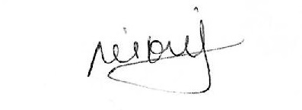 | Date:  10 Nov 2023
Manager Signature: | Date:  10 Nov 2023

Please submit to Payroll once approved.

